Structures and Classes

LAB # 10&11



Spring 2022

CSE-102L COMPUTER PROGRAMMING LAB

Submitted by: MUHAMMAD SADEEQ

Registration No.: 21PWCSE2028

Section: C

"On my honor, as student of University of Engineering and Technology, I have neither given nor received unauthorized assistance on this academic work.'

Student Signature: _____________________

Submitted to:

Engr. Abdullah Hamid

(July 2022)

Department of Computer Systems Engineering University of Engineering and Technology, Peshawar

# Lab 10 & 11: Structures and Classes

## Objectives:

To learn about data structures and classes in C++

## Tasks:

1. A phone number such is (091) 767-8900 can be thought of as having three parts: the area code (091), exchange (767) and number 8900. Write a program that uses structure to store these 3 parts of a phone number separately. Assume name of the structure is ‘phone’. Create two objects of type ‘phone’, initialize one object and take the other one from the user. Display both numbers.

Sample Run:

Enter you Area code, exchange, and number: 091 767 8900

My number is (042) 867-4982

Your number is (091) 767-8900

1. Write a C++ Program where you create a movie database using structures. i.e the struct must have two members “title” and “year”. For test run add 3 movies into the database and then display the move title and names.
2. A point on a two-dimensional space has two numbers: an ‘X’ coordinate and a ‘Y’ coordinate such as (4, 5). Write a program that uses a structure called ‘point’ to model a point and draw a rectangle of ‘*’ based on the entered height and width of the rectangle.

Sample Run:

Enter the point coordinates: (x, y)

3 2

Enter width of the rectangle: 3

Enter Height of the rectangle: 2

* * *

* * *

1. Write a program to develop student information system. This system should be able to take the student’s credentials, like name, reg no and semester no, as input and store them in a structure object Student_t. The system should be capable of storing the information of multiple students.

And it should be capable of displaying the student’s information, when asked to do so, via reg no.

1. Make a C++ Program that will have a Class of your choosing. You can pick your own concept it doesn’t need to be a specific Class (for example we in lab we made a class about rectangle choose anything like that). Your class must contain the following:

* Constructor
* Member functions
* Data members
* Destructor

**COMPUTER PROGRAMMING LAB # 10**

**Answer #1**

**CODE:** 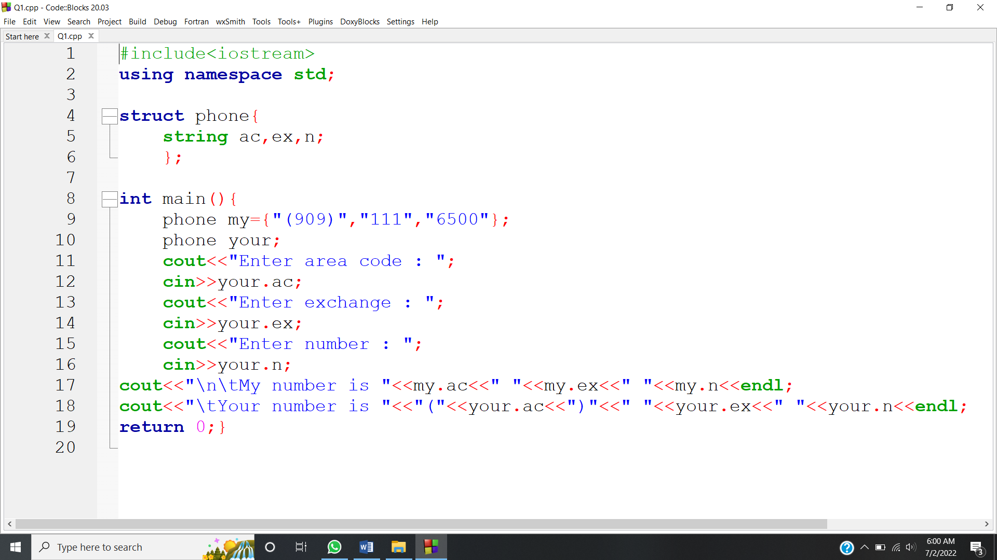

**OUTPUT:** 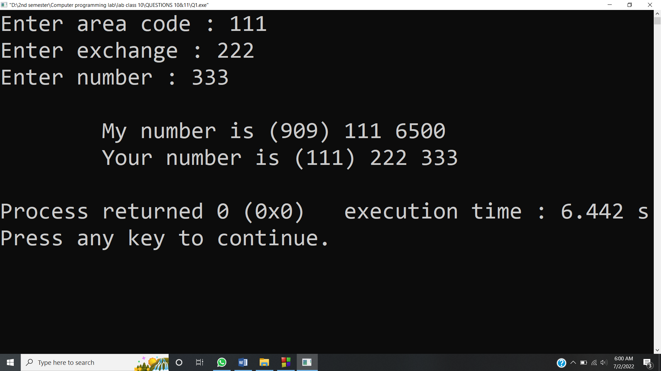

**Answer #2**

**CODE:** 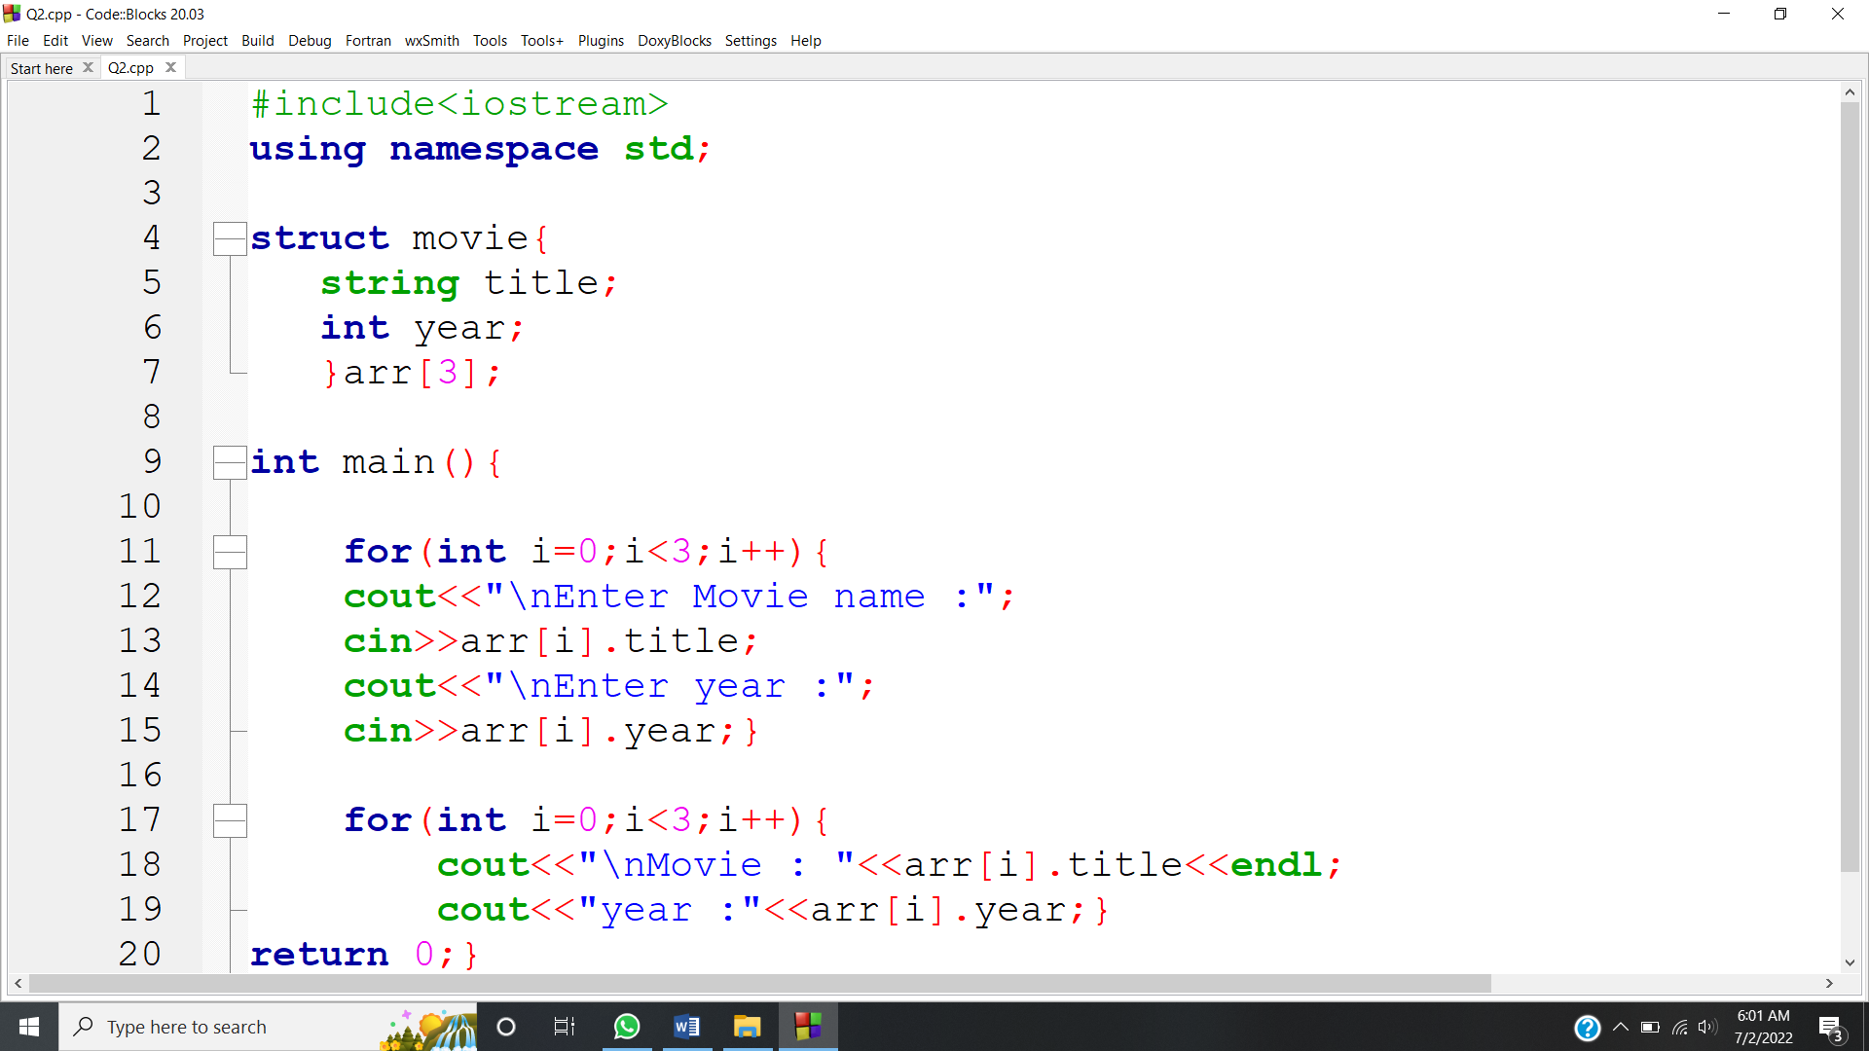

**OUTPUT:** 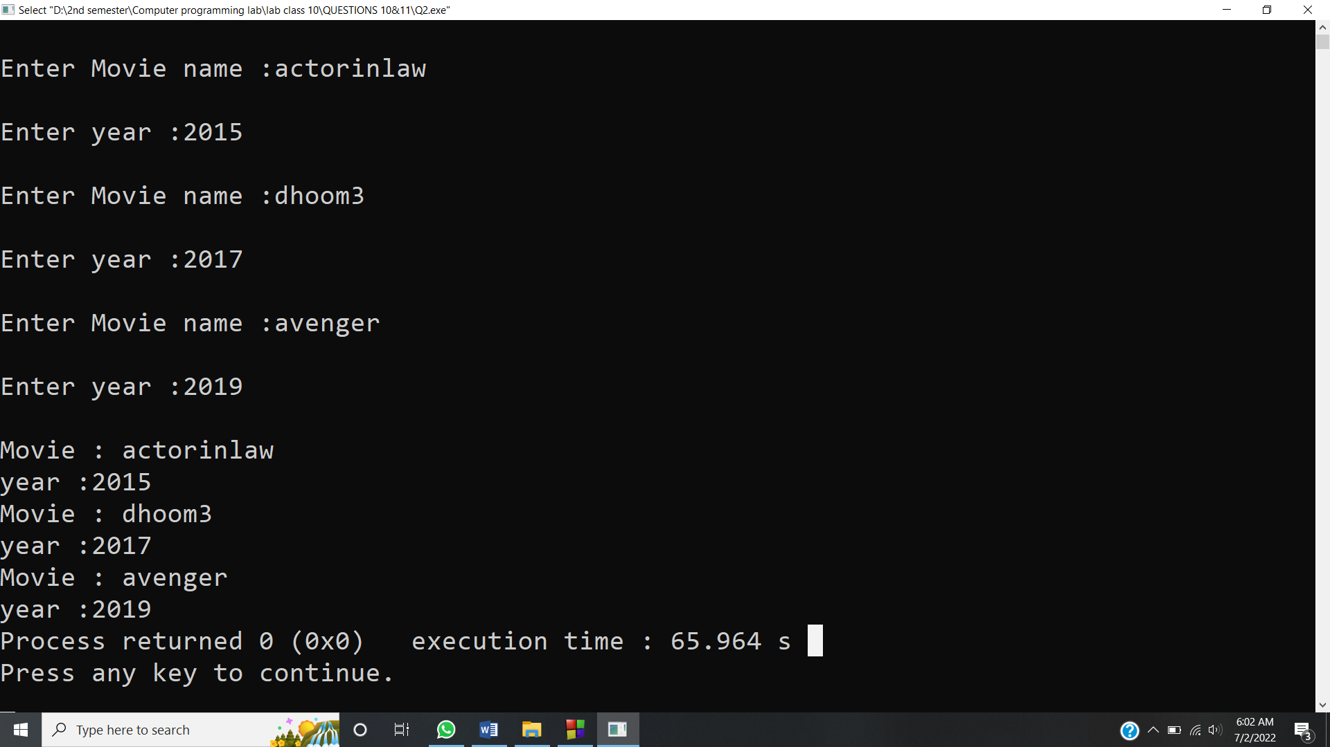

**Answer #3**

**CODE:** 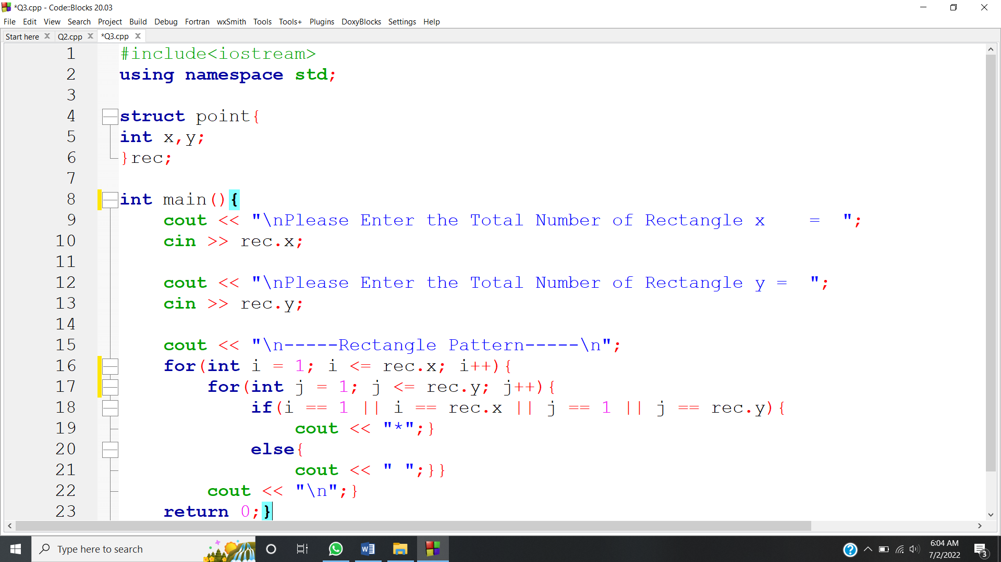

**OUTPUT:** 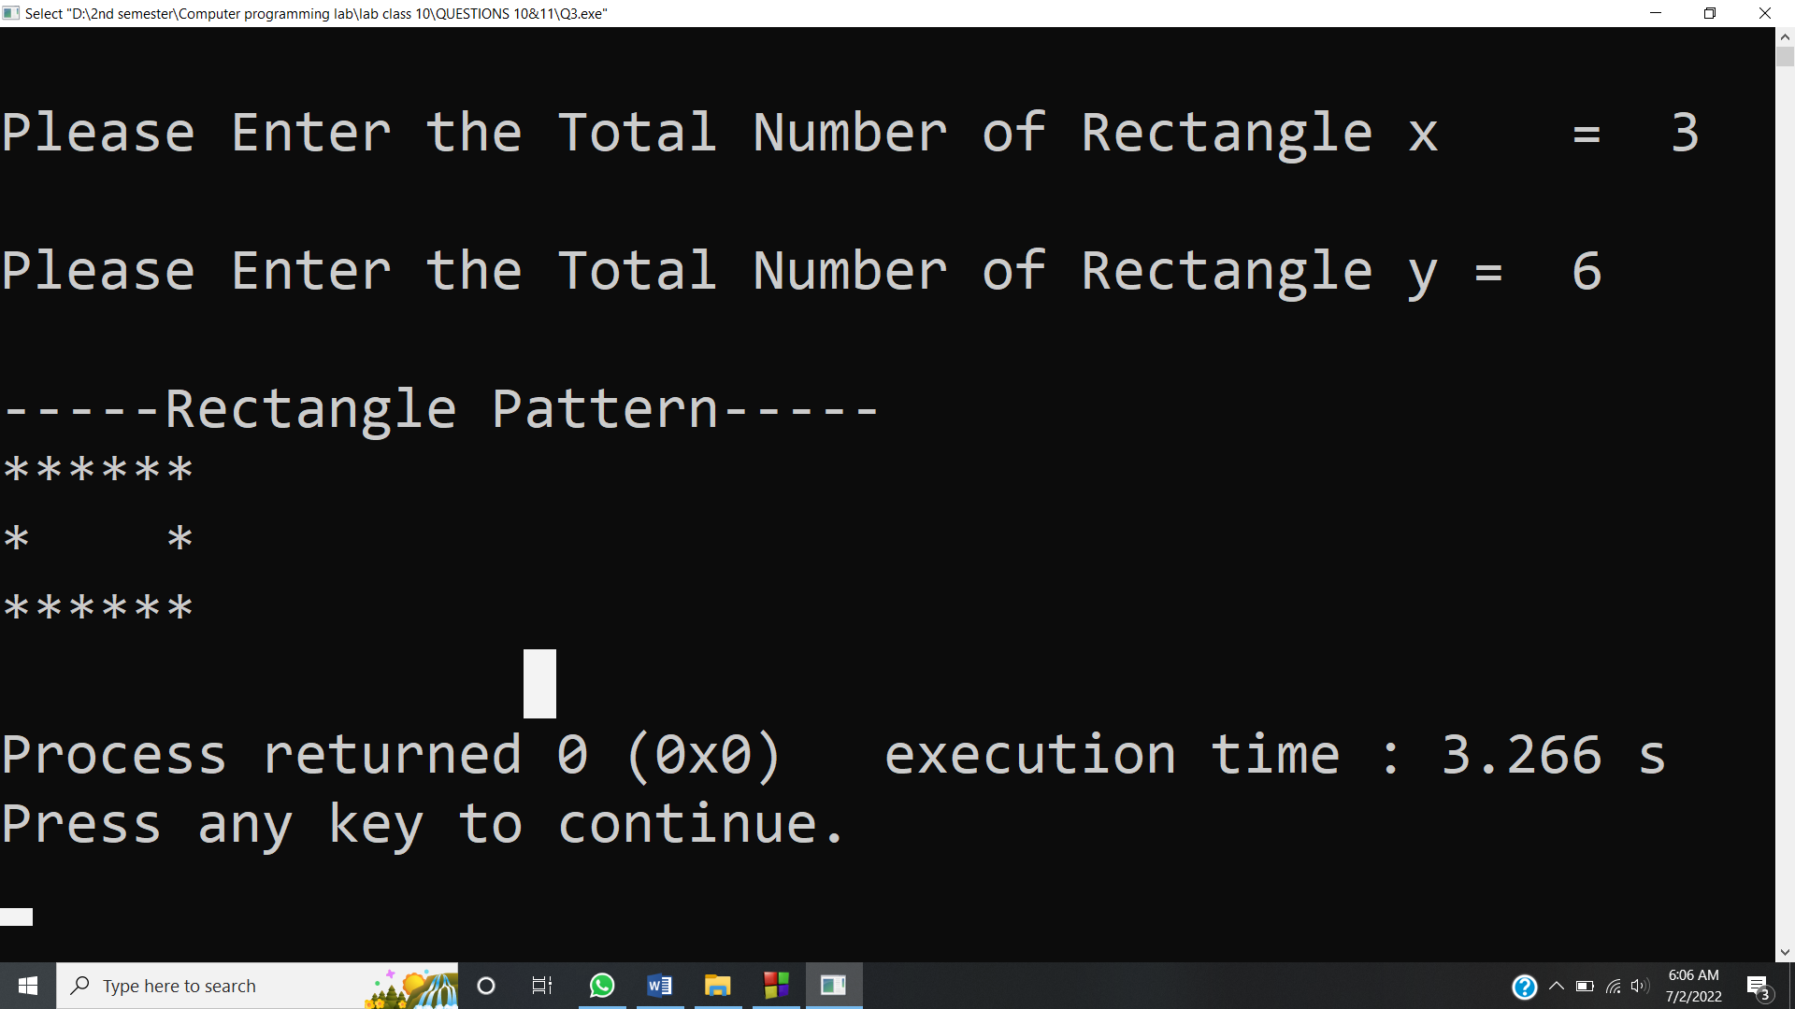

**Answer #4**

**CODE:** 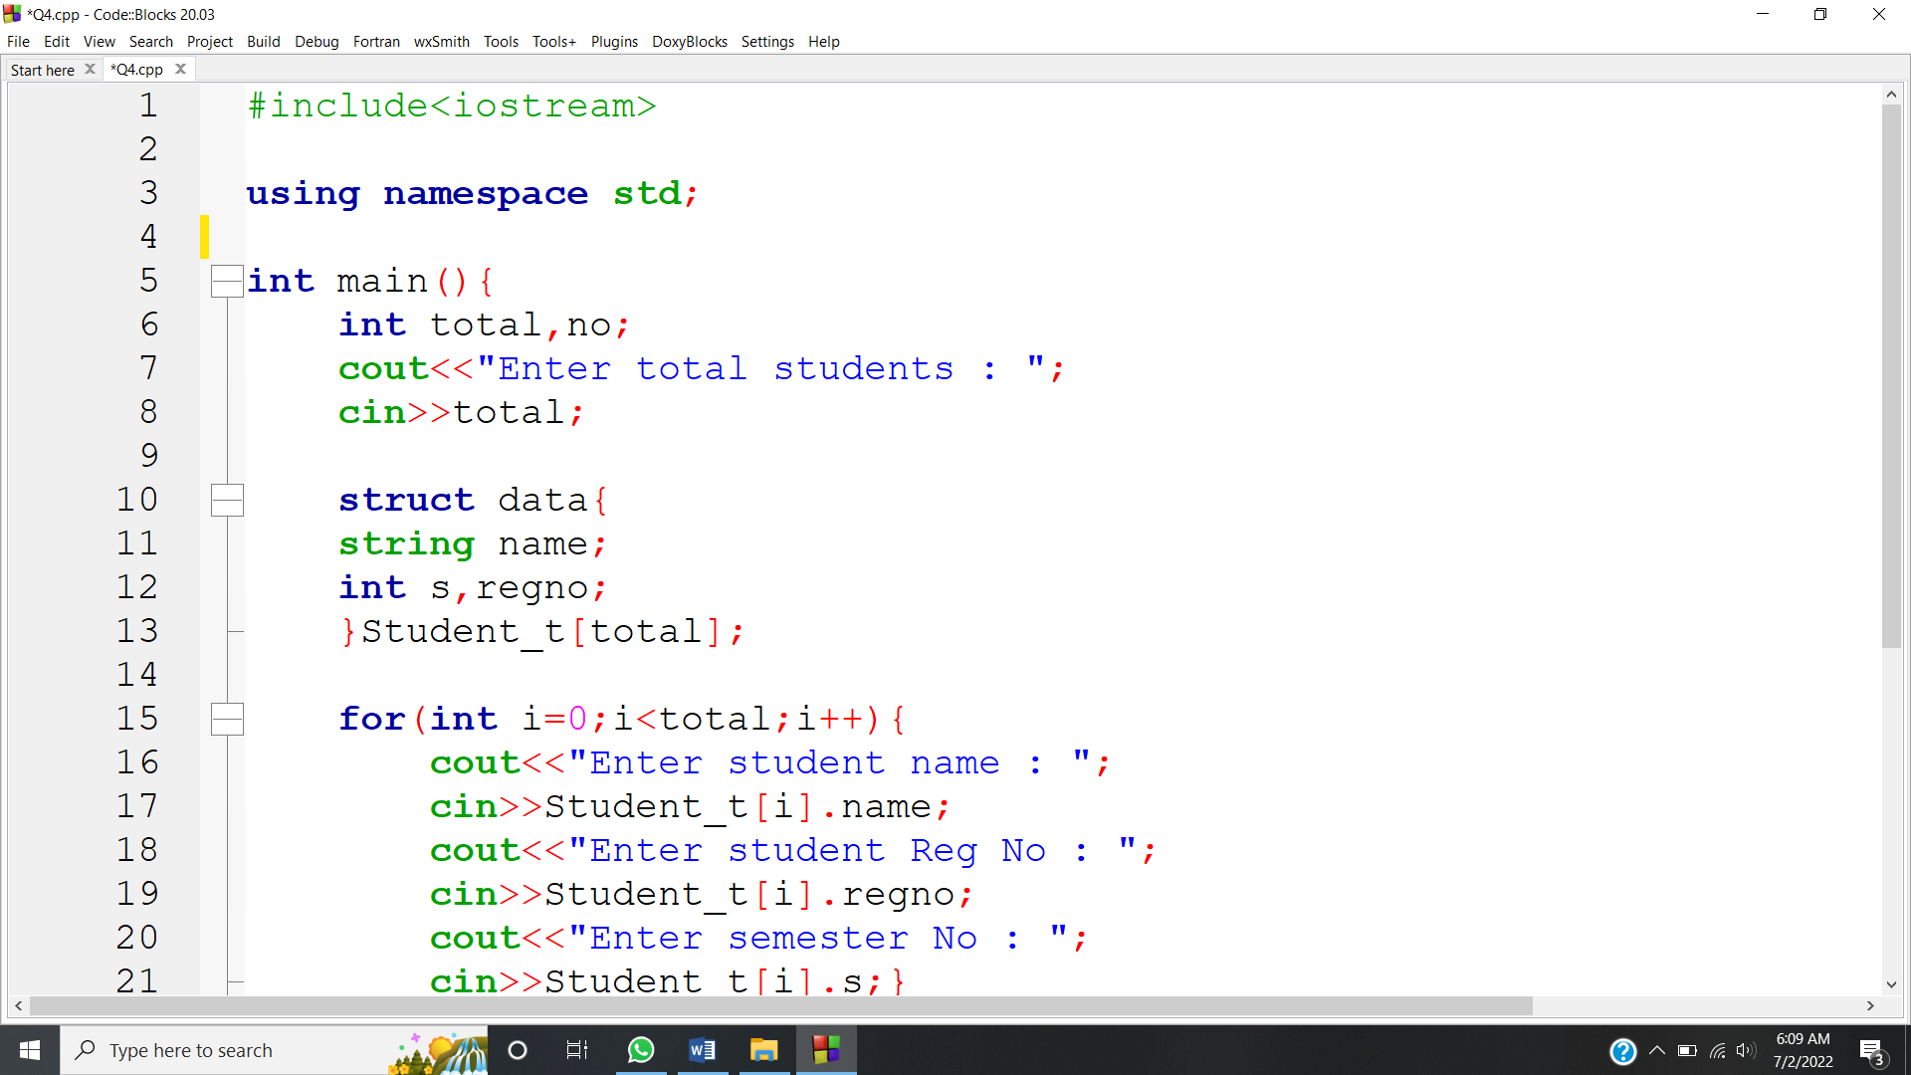 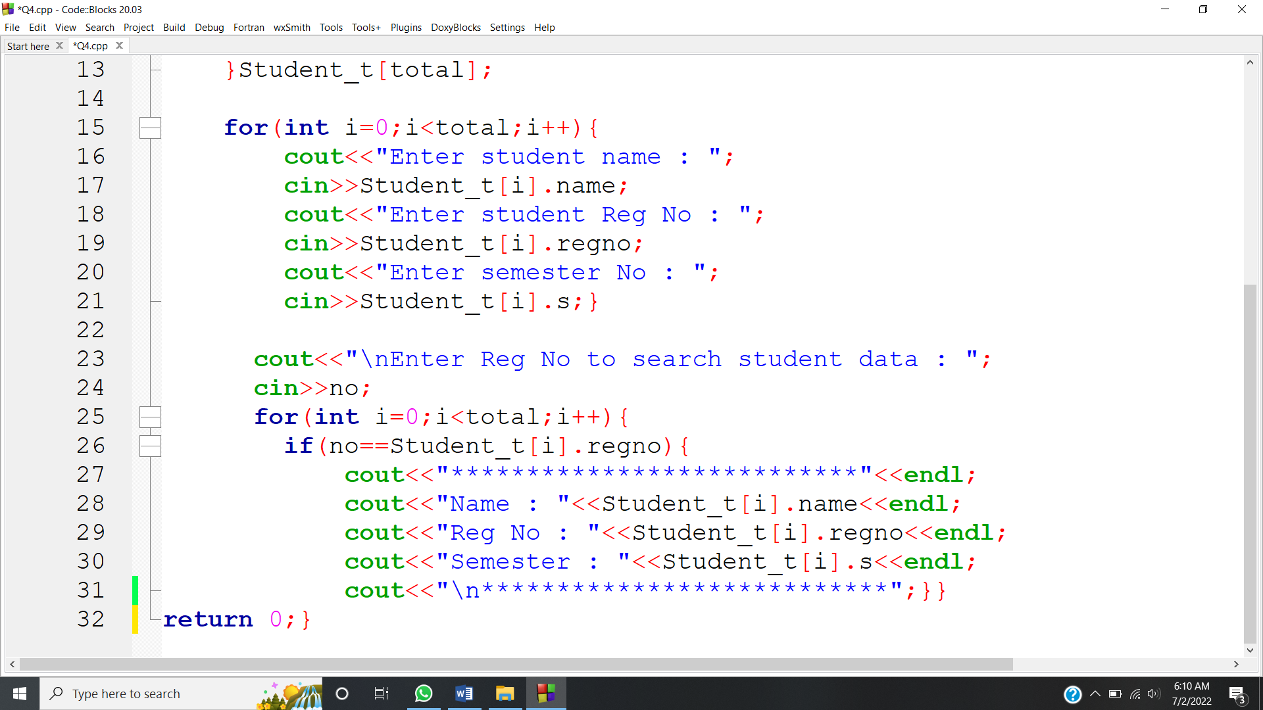

**OUTPUT:** 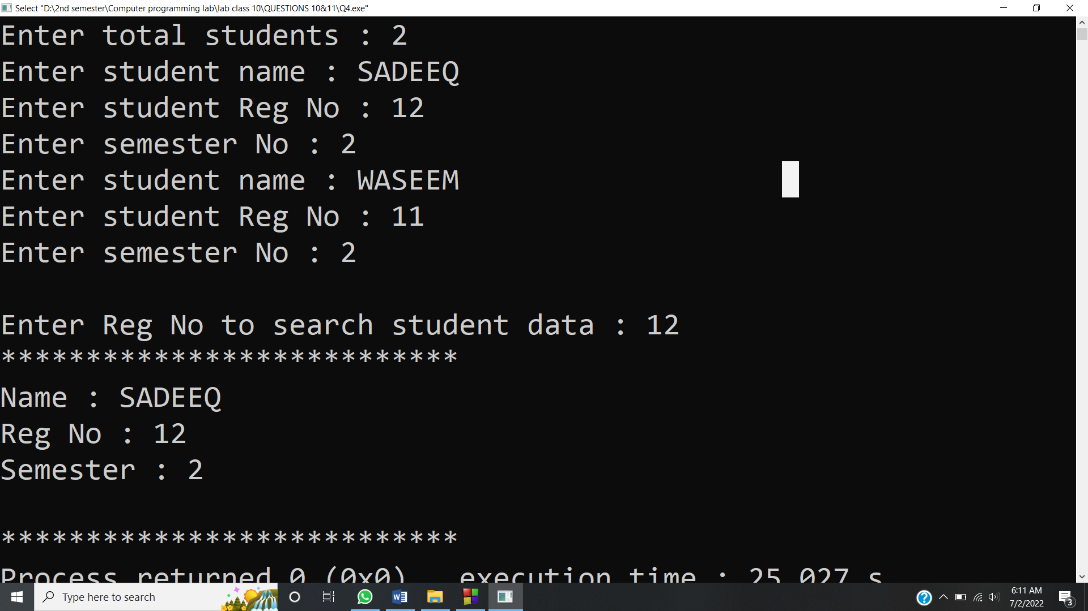

**Answer #5**

**CODE:** 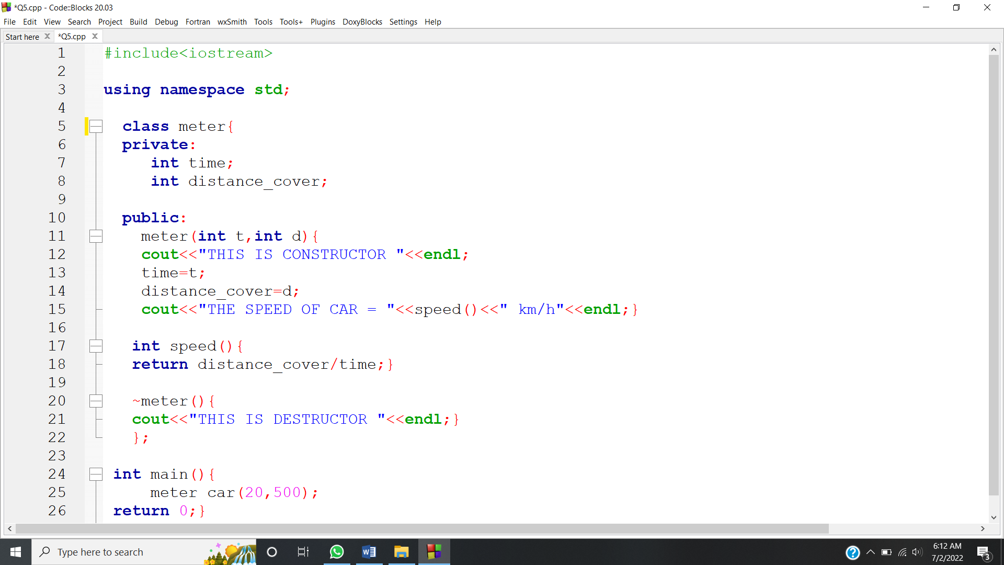

**OUTPUT:** 